|  |  |  |  |
| --- | --- | --- | --- |
| **Department of Software Engineering**  **Mehran University of Engineering and Technology, Jamshoro** | | | |
| **Course: SWE121 – Object Oriented Programming** | | | |
| **Instructor** | Mr. Asmatullah | **Practical/Lab No.** | 07 |
| **Date** | 15-08-2022 | **CLOs** | CLO-3 |
| **Signature** |  | **Assessment Score** | 1 Marks |

|  |  |
| --- | --- |
| **Topic** | **Demonstrating Threads and Multi-Threaded Programming logics** |
| **Objectives** | * Understand the threads, multithreaded programming and its need in programming. * To write the code to define instantiate and start new threads using both ***java.lang.Thread*** and ***java.lang.Runnable.*** * To recognize the condition that might prevent a thread from executing. * Understanding the thread states and the transition between them. |

|  |
| --- |
| **Lab Discussion: Theoretical concepts and Procedural steps** |

**Tools:**  Java Development Kit, Text Pad, Netbeans, Eclipse

**Theory**

Outline

* Describe Multithreading and Advantages of Multithreading.
* Defining the Thread class. Creating, starting and stopping a thread.
* To learn how to Implement Multithreading in programs.
* To understand what a daemon thread does.

Java is a multi-threaded programming language which means we can develop multi-threaded program using Java. A multi-threaded program contains two or more parts that can run concurrently and each part can handle a different task at the same time making optimal use of the available resources specially when your computer has multiple CPUs.

By definition, multitasking is when multiple processes share common processing resources such as a CPU. Multi-threading extends the idea of multitasking into applications where you can subdivide specific operations within a single application into individual threads. Each of the threads can run in parallel. The OS divides processing time not only among different applications, but also among each thread within an application.

Multi-threading enables you to write in a way where multiple activities can proceed concurrently in the same program.

## Life Cycle of a Thread

A thread goes through various stages in its life cycle. For example, a thread is born, started, runs, and then dies. The following diagram shows the complete life cycle of a thread.

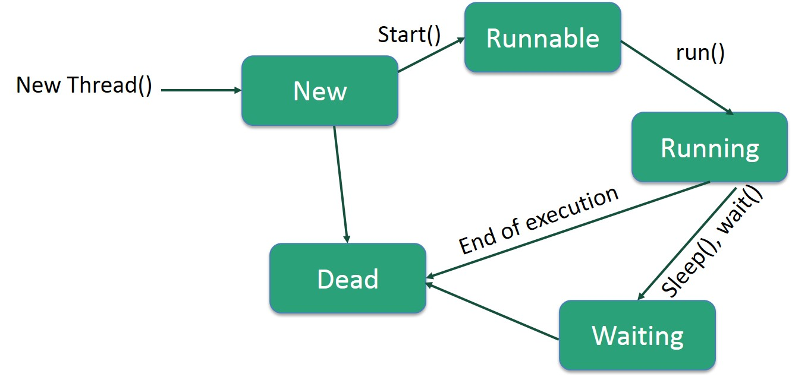

|  |
| --- |
| **Lab Tasks** |

1. Write a program based on threads. Perform multi-threading and print even and such that when the numbers reach at value 30 then give a delay of 5 seconds. After the delay, the program will continue to print the series at the same manner.
2. Create three classes, Storage, Counter, and Printer. The Storage class should store an integer. The Counter class should create a thread that starts counting from 0 (i.e. 0,1, 2,3,4….) and stores each value in the Storage class. The Printer class should create a new thread that keeps reading the value in the Storage class and printing it.